### CRL Polished Brass End Cap for 1/2" Deep U-Channel

**Finish/Color :** Polished Brass

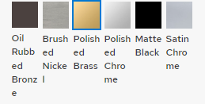

**Item #:** SDCEC12BR

View Prices with a Purchase Account

Minimum Order Quantity : 10

Unit of Measure : each